County Hall
Bythesea Road
Trowbridge
Wiltshire
BA14 8JN

20th June 2023

Dear parents/carers,
I know many of you will have been shaken to have heard about the tragic event recently with the fatal stabbing of Mikey Roynon in Bath.
I appreciate this can cause concern and worry and I’m sure young people will have been discussing among themselves and potentially with you.
As you know, Avon and Somerset police is conducting a thorough investigation and they are providing regular updates on their website www.avonandsomerset.police.uk.
For our part, we know these types of events can make young people feel anxious and I would like to share some help which is available for young people in Wiltshire.
There is support available for example from Shout: you can text WILTS to 85258 to receive free, confidential support from a trained volunteer via text message, this is available for all ages and is a free service. There is also Childline: call 0800 11 11 (under 19) and the On Your Mind service with advice and support Children and Young People – On Your Mind. ChatHealth is a school nurse messaging service and young people can text 07480 635 513 at any time, and they will get back to the young person between 9am and 4pm on 07480 635 513.
If a crime is being committed or an incident is ongoing police advise to call 999 immediately. If you have information about a planned event, or concerns about someone who may be carrying a knife, call 101.
Your school will also have support systems in place and will be able to offer help and advice so please do use them.
I hope this provides some reassurance and useful information.

Yours faithfully
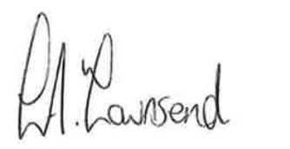

Lucy Townsend
Corporate Director People (DCS)

